**HOUSE PRICE PREDICTION**

**USING MACHINE LEARNING**

**DONE BY: AFREEN FATHIMA M**

**INTRODUCTION**

* House Price Prediction Using Machine Learning aims to build an estimation tool that predicts the approximate price of a house based on the features such as number of bedrooms, number of bathrooms, overall scores and historical data.
* Using a machine learning algorithm, the model learns the pattern and relationship between various features and house price.
* The goal of this project is to build a reliable and user-friendly web application using Python Flask, HTML, CSS (Bootstrap 5), JavaScript, where users would be able to enter their preferred data and receive the price estimates as a result.
* This project would not only provide insights for the buyers to buy a house at the relevant price but also help the sellers to price the property fairly.

**OBJECTIVE**

* To build a model that predicts the price of the house using machine learning
* To integrate the model into the web application
* To create engaging platform for the house price predicting users to get informed decisions.
* To improve the responsiveness of the application

**SCOPE**

* Integrating the house price prediction model into the web application built using Python Flask, HTML, CSS (Bootstrap 5), JavaScript
* Displaying the predicted price in a user friendly application.

**EXISTING SYSTEM**

* Current Existing systems are either manual which leads to inaccurate price estimation.
* Or lack user interaction which becomes difficult and time consuming for the buyers to buy the house at relevant price and sellers to sells the house at the reliable price preventing the loss

**PROPOSED SYSTEM**

* Our project aims to overcome this traditional method of predicting house price by integrating our model into an interactive web application where user would be able to input their desired property details and get the estimated price as a result based on the trained model.
* Our model takes various features, trains the model based on the historical data and learns the pattern and relationship between each features to provide a reliable price estimates by comparing the accuracy of the price with different models.

**METHODOLOGY DIAGRAM**

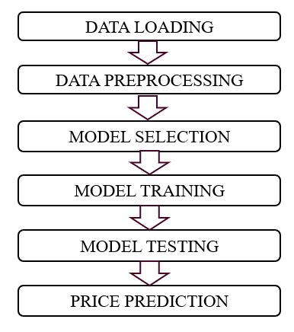

**DATAFLOW DIAGRAM**

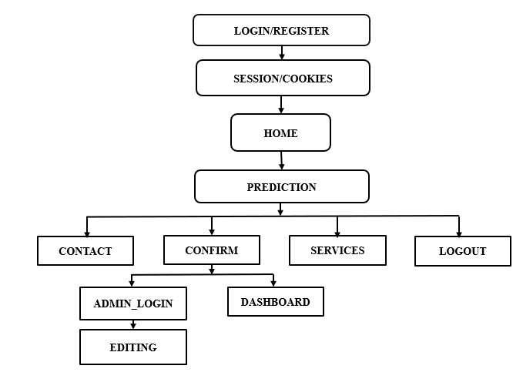

**SCREENSHOTS:**

**WELCOME PAGE**

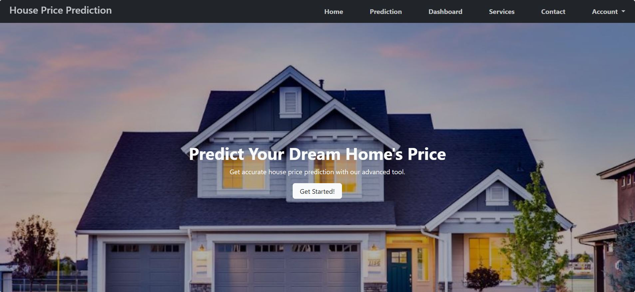

**REGISTER PAGE**

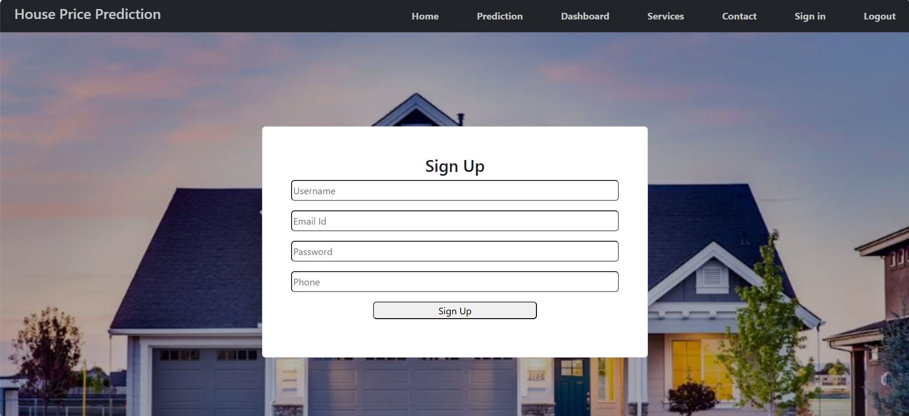

**LOGIN PAGE**

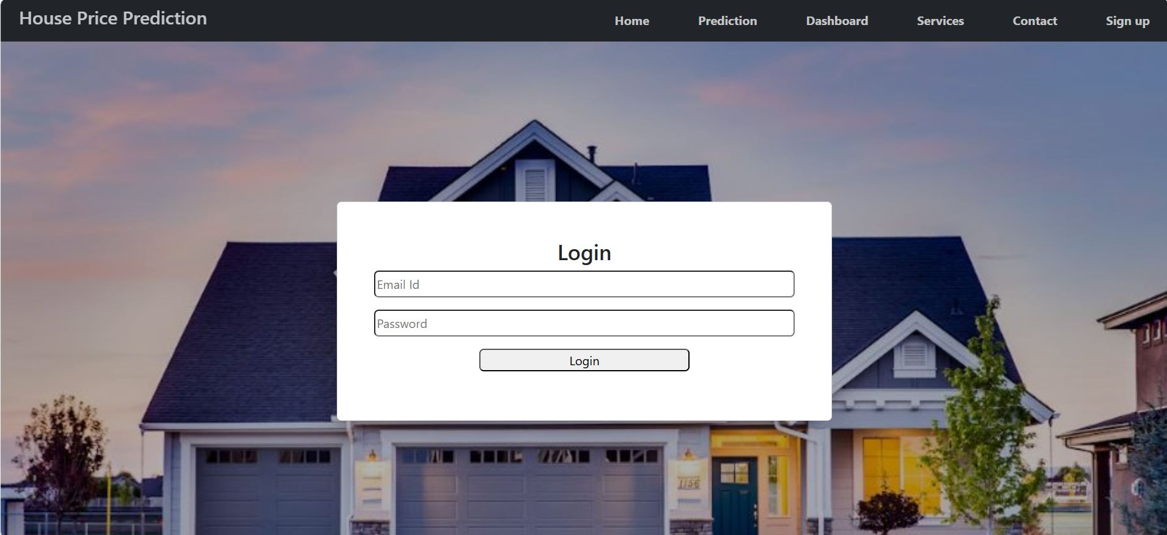

**CONTACT/FEEDBACK PAGE**

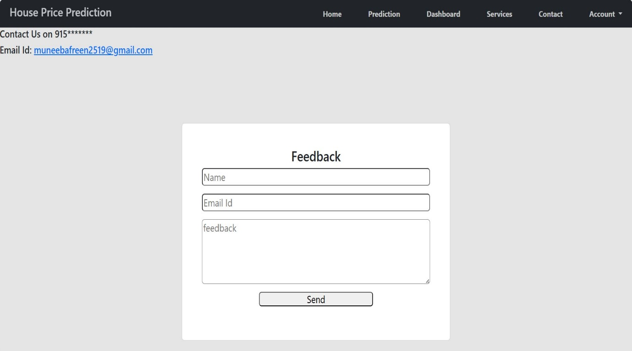

**PREDICTION PAGE**

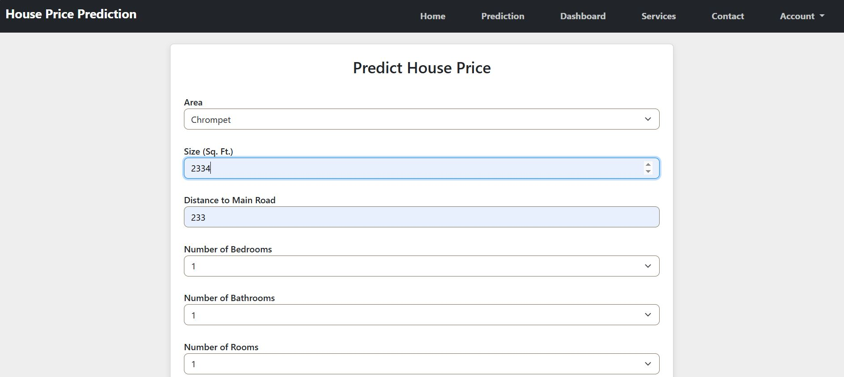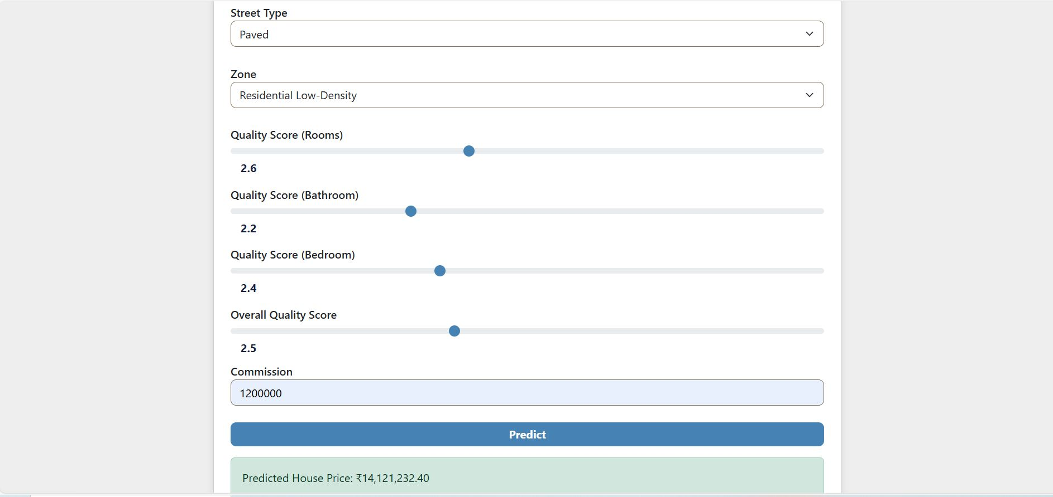

**SERVICES PAGE**

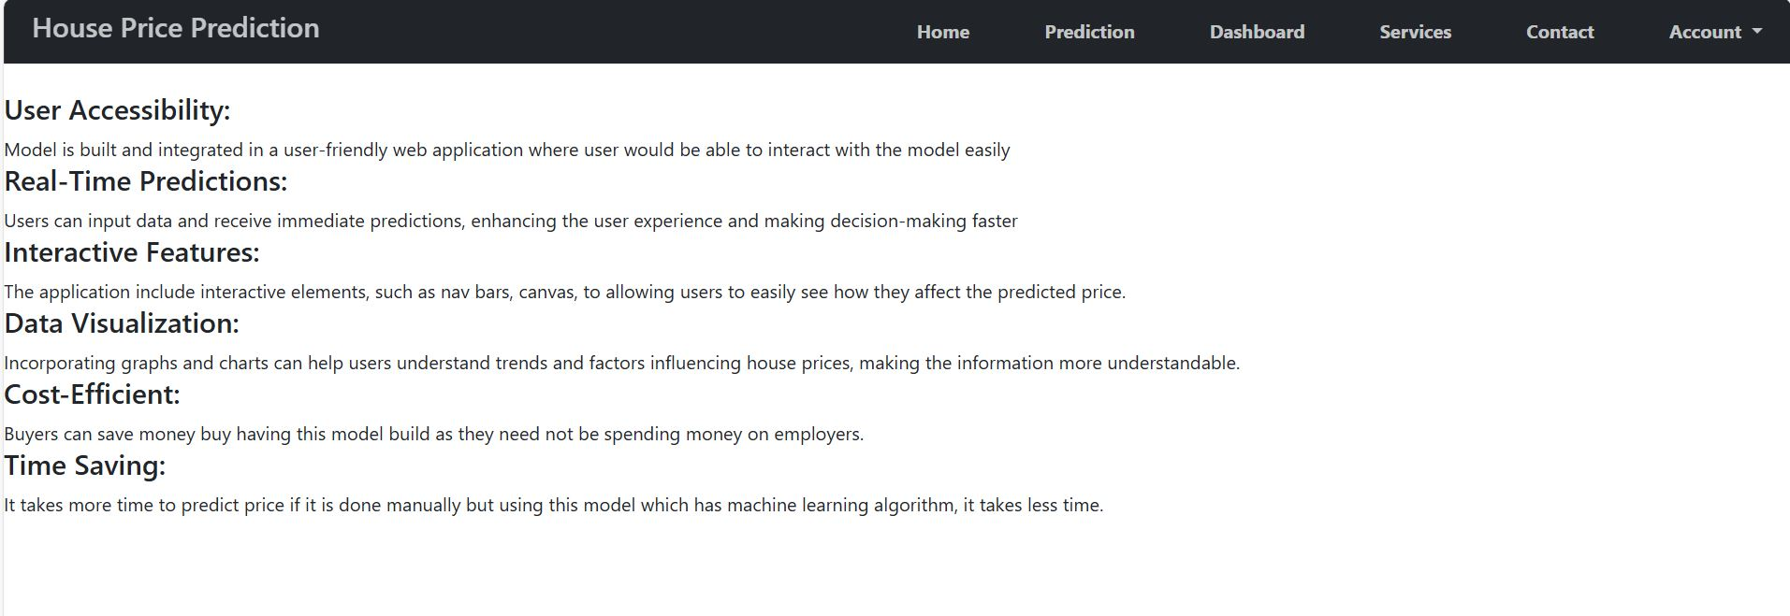

**ADMIN LOGIN**

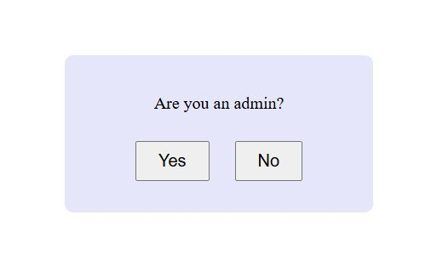

**IF YES**

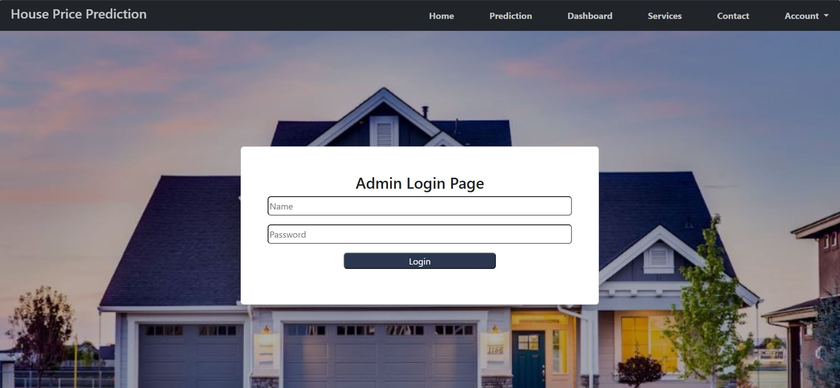

**ADDING DATA WITHIN THE CURRENT RECORDS**

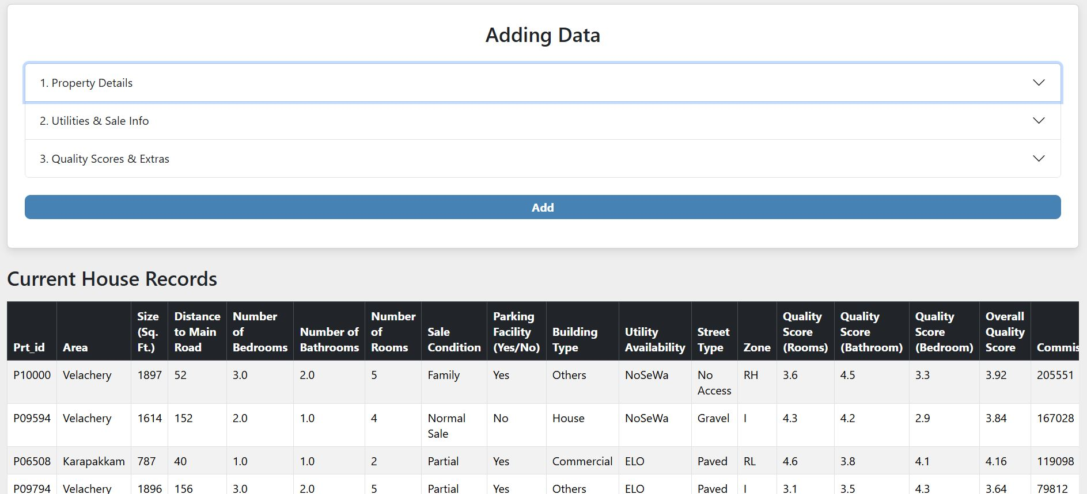

**IF NO**

**REPORT PAGE:**

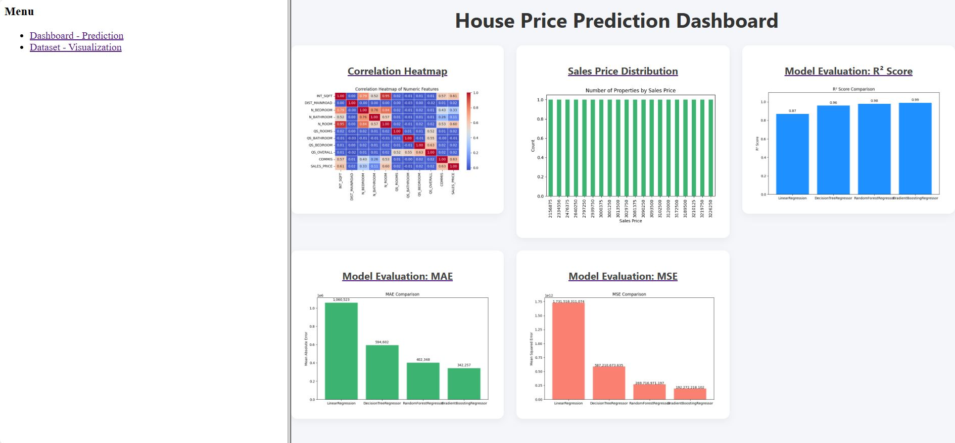

**REPORT CONTINUATION**

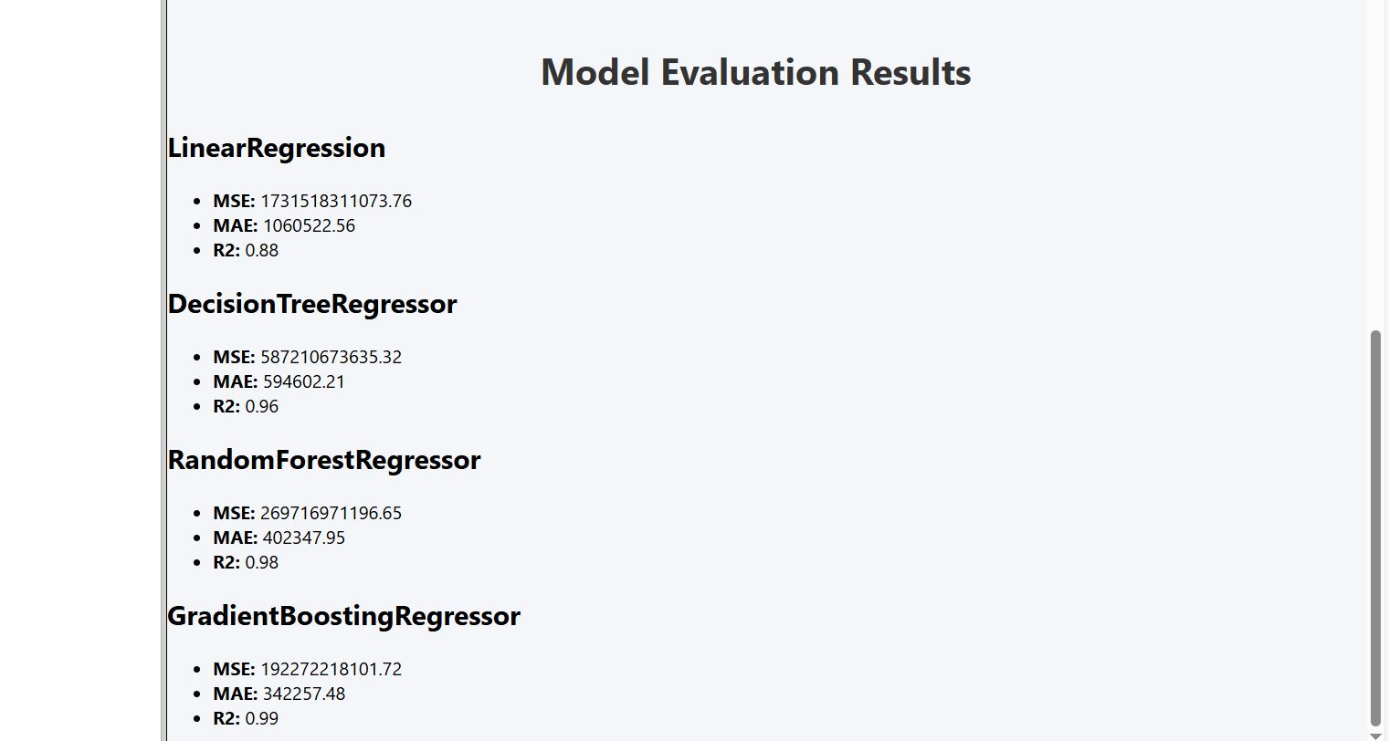

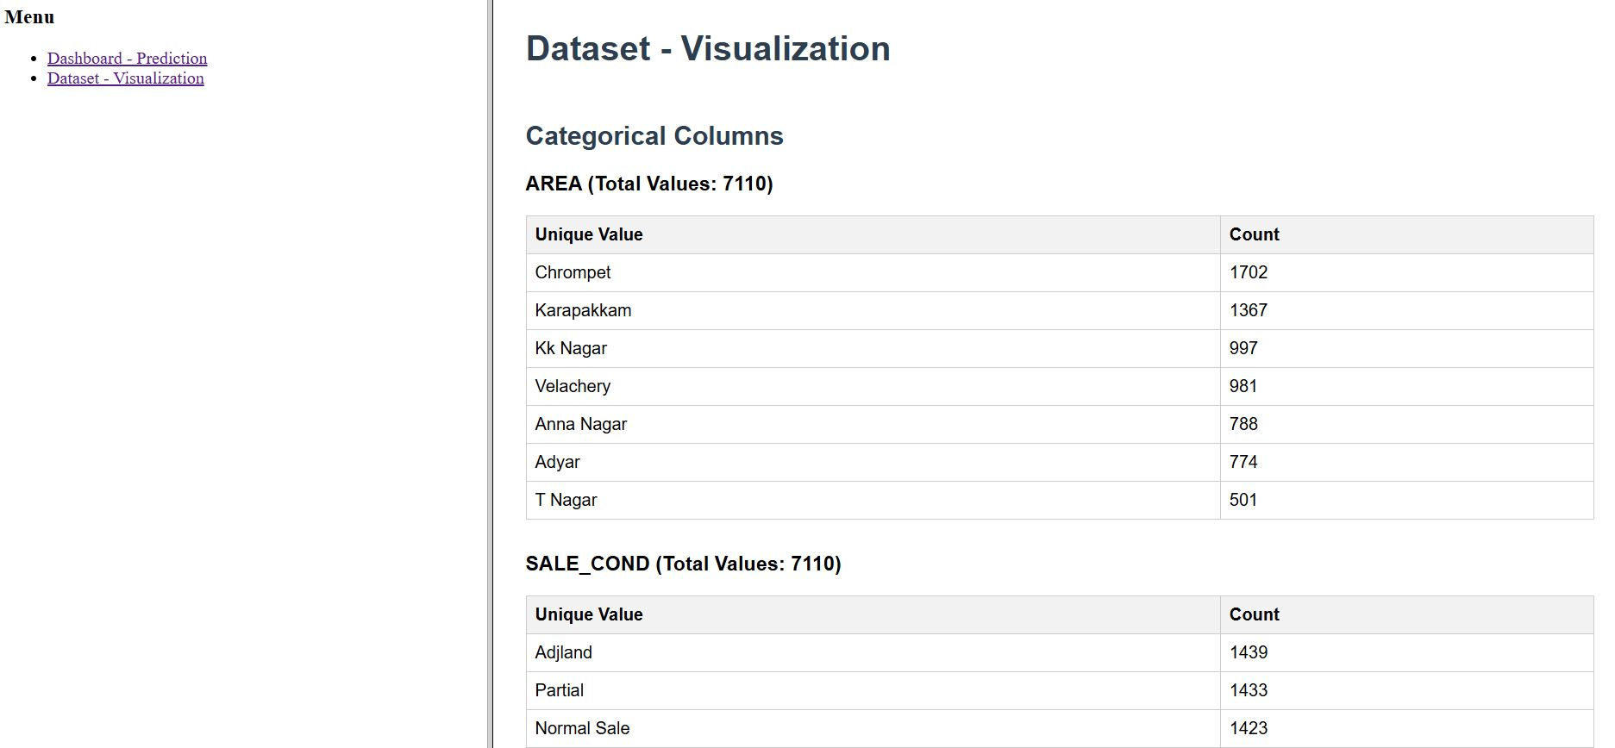

**CONCLUSION**

* This project has successfully developed and implemented a machine learning-based House Price Prediction system specifically tailored for properties in Chennai.
* By analysing various features the system provided a reliable price estimates.
* Among various algorithm, Random Forest Regression provided a reliable accuracy and performance
* The solution is deployed within a user-friendly web application and enabled the user to input property values.
* Various visuals and summaries were provided to get the insights.
* Hence, this project offers fast and cost-efficient technique which overcomes the traditional method of property pricing.

**CHALLENGES AND SOLUTIONS**

* **Challenge 1:** Some parts of the forms were lacking responsiveness

**Solution:** Adjusted margin and padding using the bootstrap5 and tested it on different platforms.

* **Challenge 2:** User were facing issues by integrating incorrect values for the prediction

**Solution:** Integrated the dropdown options for the categorical values and updated it with validation

**LIMITATIONS**

* **Time Consuming:** User need to manually insert random data which might be time consuming for them.
* **Storage:** It takes a little high storage capacity
* **Feature Selection:** Feature can only be added by the admin

**MERITS**

* **User Accessibility:** Model is built and integrated in a user-friendly web application where user would be able to interact with the model easily
* **Real-Time Predictions:** Users can input data and receive immediate predictions, enhancing the user experience and making decision-making faster
* **Interactive Features:** This application includes interactive elements, such as navbars, elements to allow users to easily see how they affect the predicted price.
* **Data Visualization:** Incorporated graphs and charts which help the user to understand trends and factors influencing house prices, making the information more understandable.
* **Cost-Efficient:** Buyers can save money by having this model build as they need not be spending money on employers.
* **Time Saving:** It takes more time to predict price if it is done manually but using this model which has machine learning algorithm, it takes less time.

**FUTURE ENHANCEMENT**

* **Mobile Application Integration:** Develop a mobile version for increased accessibility and convenience.
* **Multilingual Support:** Enable the application in multiple languages, including Tamil for various different language users**.**
* **Geographical Data Visualization:** Add interactive maps that allow users to explore price trends in different regions or neighbourhoods of Chennai.
* **Incorporation Of Real-Time Data**: Integrate APIs to fetch real-time market data, such as property listings, to improve prediction performance.
* **Admin Dashboard Enhancements:** Admin would be able to add features in the datasets using dashboards.

**BIBLIOGRAPHY**

* [**https://www.w3schools.com/html/default.asp**](https://www.w3schools.com/html/default.asp)
* [**https://www.w3schools.com/css/default.asp**](https://www.w3schools.com/css/default.asp)
* [**https://www.w3schools.com/js/default.asp**](https://www.w3schools.com/js/default.asp)
* [**https://www.w3schools.com/bootstrap5/index.php**](https://www.w3schools.com/bootstrap5/index.php)
* [**https://www.w3schools.com/mysql/default.asp**](https://www.w3schools.com/mysql/default.asp)
* **Flask Document (official)**

[**https://flask.palletsprojects.com/en/stable/**](https://flask.palletsprojects.com/en/stable/)

* [**https://www.w3schools.com/python/default.asp**](https://www.w3schools.com/python/default.asp)
* [**https://www.geeksforgeeks.org/machine-learning/**](https://www.geeksforgeeks.org/machine-learning/)